|  |
| --- |
| YEAR 12 Essentials Mathematics  Semester 1 2017  Test 2 - **Volume, Capacity, 2D & 3D shapes, Scale, plans.**  **.** |
| Total Marks: 45 marks  Name: ______________________ Total Time: 50 minutes |



***Full working out must be shown to get full marks.***

***Attempt all questions***

**Total Time: 60 minutes**

***Resources allowed:***

***1 A4 page, (1 side) of hand written notes,ruler***

***Calculator***

1. Find the Volume for each figure… [2, 2, 2, 2, 2-10 Marks]
2. Volume = _______

7cm

21 cm

1. Volume =_______

9m

6m

18 m

1. Volume =_______

22m 33m

44 m

1. Volume =_______

12cm 14cm

11cm

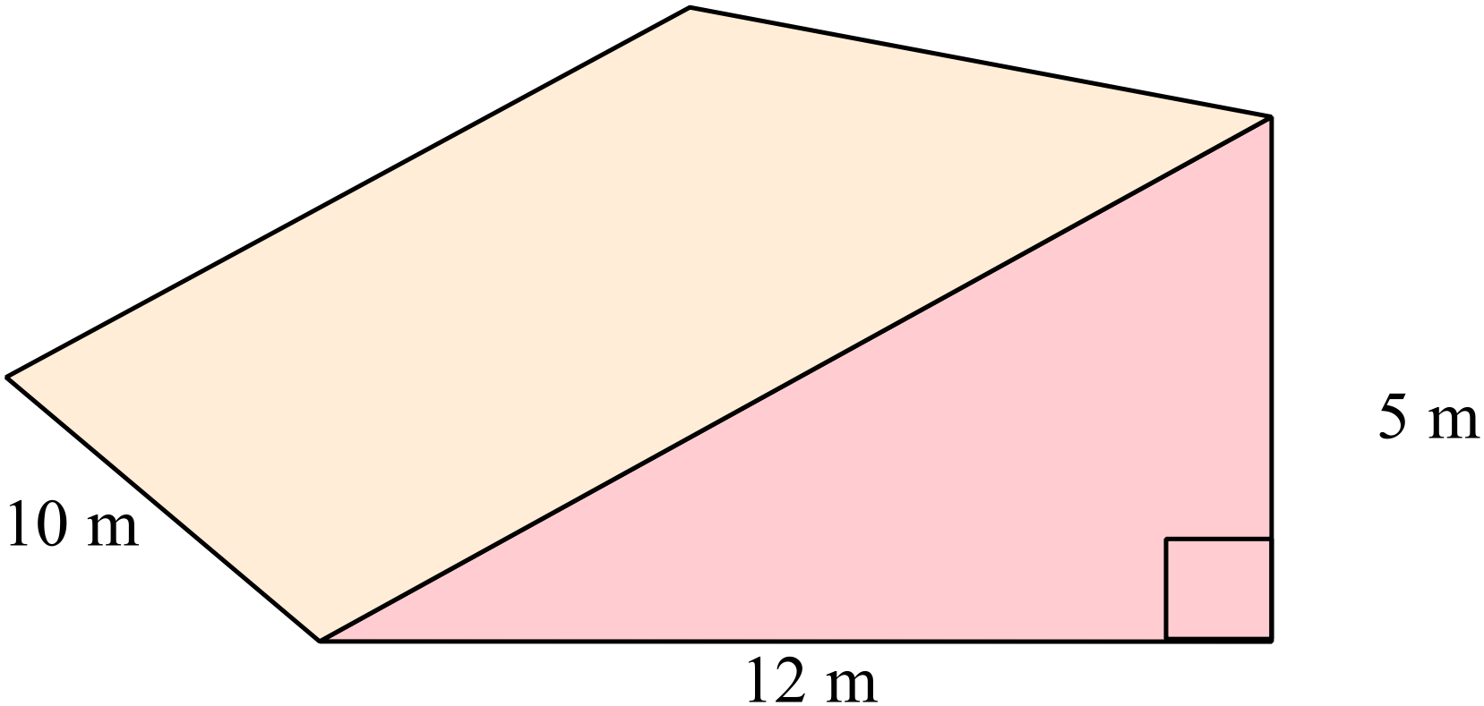

e) Volume =_______

1. Convert the following measurement to the units specified: [1,1,1,1 - 4 marks]

a) 7500 cm3 = m3 b) 0.185 m3 = cm3

c) 9 787 200 mm3 = m3 d) 5 m3 = mm3

1. Match the nets with the following shapes: [1,1,1,1 - 4 marks]

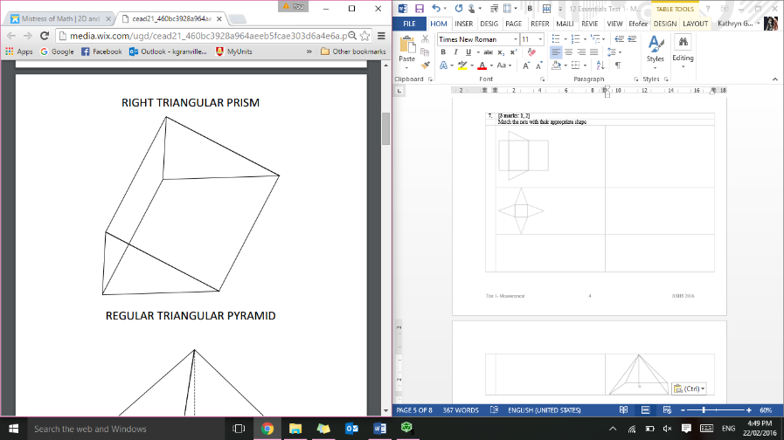

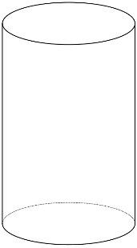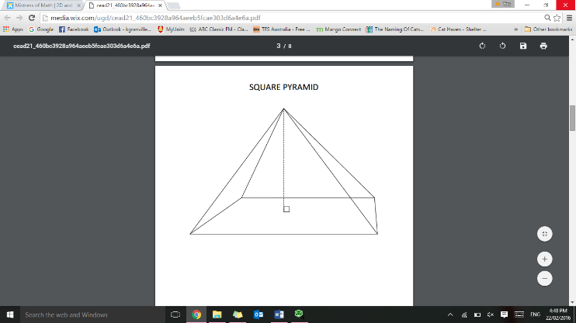

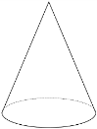

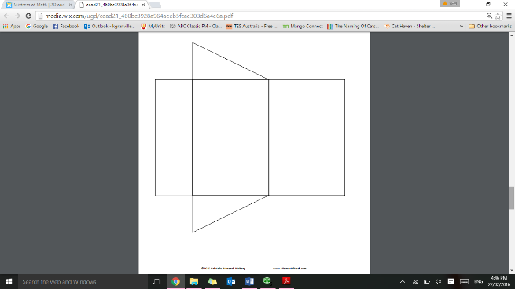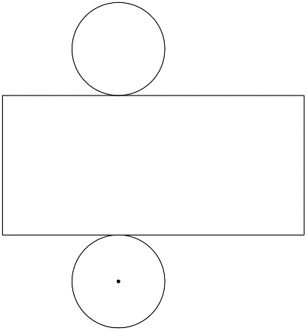

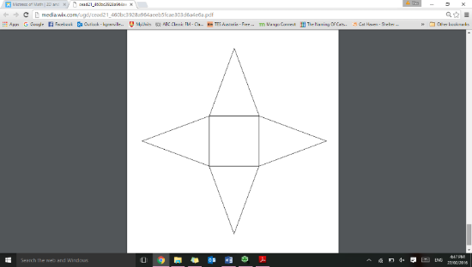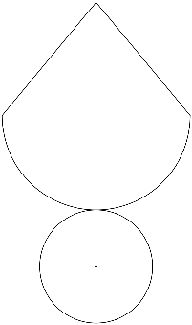

1. Thelma and David built a recycling bin that is 6 meters wide, 12 meters long, and 14 meters high. How much trash can fit inside of the bin? [3 Marks]
2. The cylindrical canister of a fire extinguisher has a radius of 4 cm and is 12 cm high. How many cubic cm can it hold? [3 Marks]
3. Sketch the following: [2, 2-4 marks]
4. A regular octagon b) An irregular hexagon
5. Cindy went to Maggie Moo’s for an ice cream cone after school. The ice cream cone had a radius of 1 cm, a height of 2 ½ cm, and a slant length of 3 ½ cm, how much ice cream could the cone hold? [3 Marks]
6. Adam is building a rectangular planter without a top. The planter will be 7 cm wide, 16 cm long, and 10 cm high. How much wood is needed to make the bottom and sides of the planter? [3 Marks]
7. Write the following scales as a ratio in its simplest form, without the units.

[1,1,1,1 - 4 marks]

1. 1 cm represents 5 cm

c) 1 cm : 350mm

1. 2cm : 20m

d) 0.5 cm : 150 cm

1. Below is the floor plan for Miss Granville’s new holiday house. [2, 2, 2,- 6 marks]

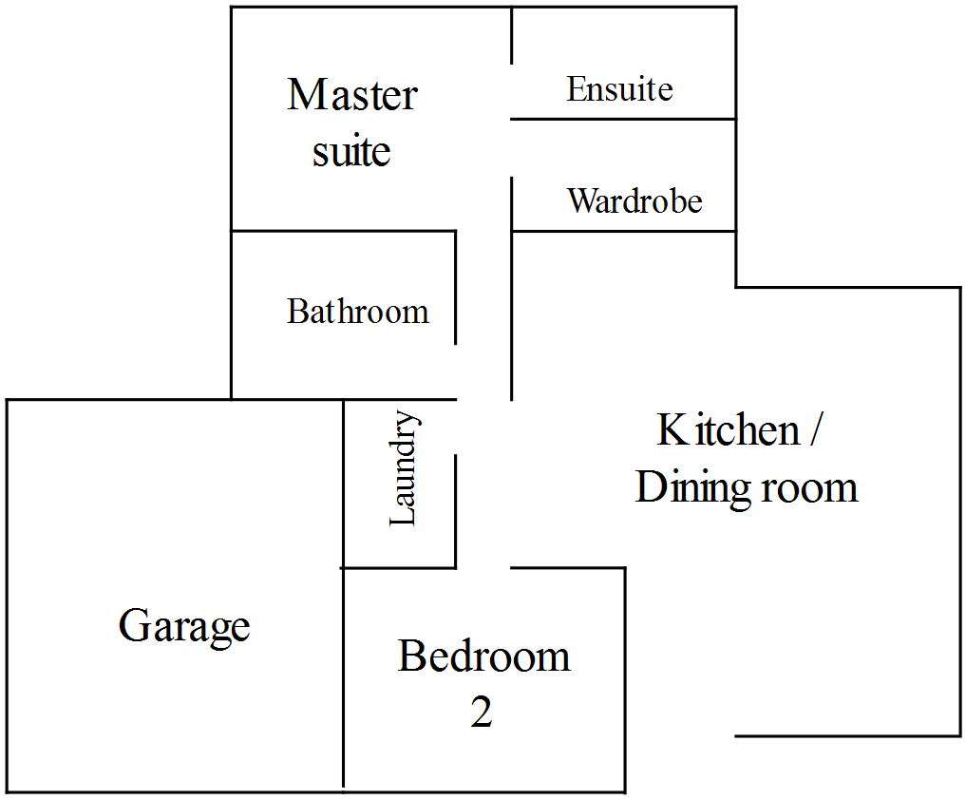

Scale 1:200

* 1. Using the scale given, find the area of the garage
  2. Miss Granville decides that she wants to concrete the floor of the garage. If concrete costs $21.20 per square metre, how much will it cost to complete?
  3. The bathroom, laundry and ensuite are to be tiled, with tiles costing $41.40/m2. How much will it cost to buy tiles?

End of Test